
Celebrating America 250
September 26, 2026, 11:00 to 4:00
Rodgers Tavern

Liberty Tree, music and history:
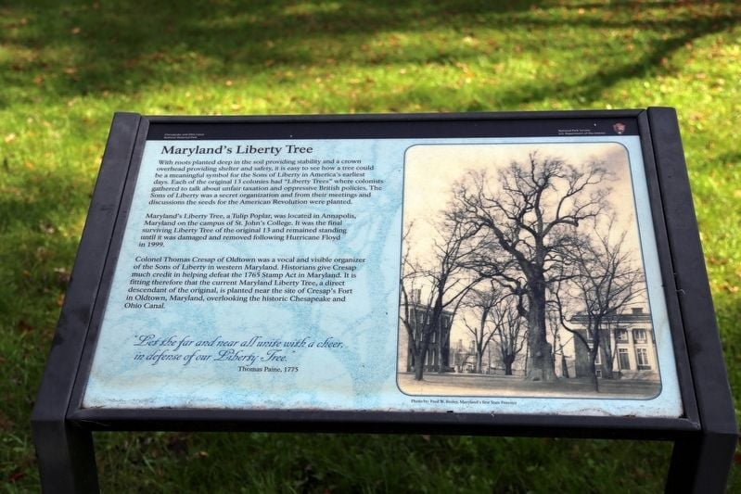
- Planting of the Liberty Tree – representatives from Maryland Forest Service and Lower Susquehanna Heritage Greenway will be in attendance for the planting of the Liberty Tree. The Maryland Liberty Tree project is a statewide commemorative project marking the 250th Anniversary of American Independence. Using seedlings grown from the only surviving genetically identical Liberty Tree scion in the US—descended from Maryland’s original 1775 Liberty Tree in Annapolis—the project will plant a Liberty Tree in each of Maryland’s 23 counties and Baltimore City. The Liberty Tree is one of the most powerful and enduring symbols of American resistance, community action, and shared civic responsibility. Before television, telephone and Facebook, residents gathered in the area of the Liberty Tree to gain knowledge and information pertaining to current events.
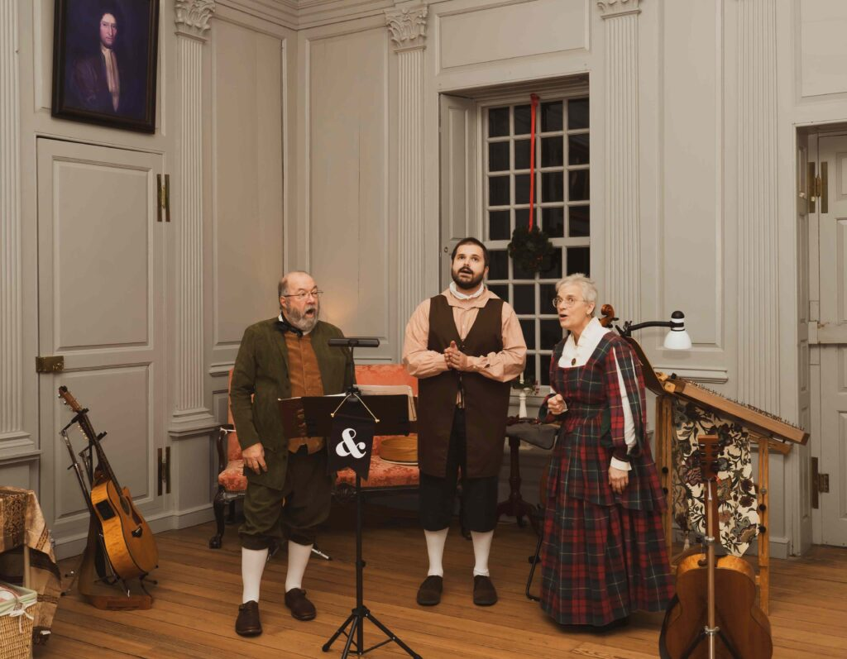
- Ampersand Music - Music of the New Nation.
Ampersand’s special concert program honors the 250th commemoration of the Declaration of Independence, and features songs and tunes of the new nation, particularly those written by contemporaries at the time. We dress in non-modern clothes and share the stories behind the songs we’ve chosen. These one-hour programs, “Music of the New Nation,” are lively and interactive, celebrating colonial music from 1730-1830. The group will perform 2-1 hour performances during the event. Times to be determined.
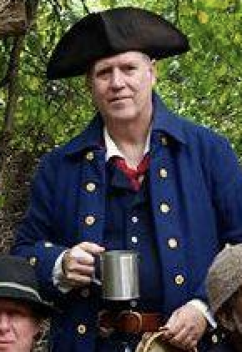
- Michael Bosworth, Director of the Ship’s Company, Chanteymen, will be in attendance as a Revolutionary War senior warrant officer and speak on naval topics, and/or bring tiny model ships depiction of a fleet battle. He recommends the Battle of Cape Henry, fought on March 16, 1781, and occurred near the mouth of the Chesapeake Bay as part of the larger conflict between British forces and the American revolutionaries, supported by the French. The Battle of Cape Henry remains a notable event in the American Revolutionary War, illustrating the complexities of naval warfare and the importance of maritime control in the conflict.

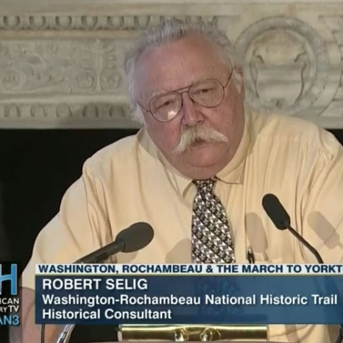
- Robert A. Selig – will speak about the activities of John Rodgers in the early stages of the American Revolution. Dr. Selig received his Ph.D. in history from the Universität Würzburg in Germany, published a number of books on the American War of Independence, is a specialist on the role of French forces under Rochambeau and serves as project historian to the National Parks Service for the Washington-Rochambeau Revolutionary route National Historic Trail Project. Dr. Selig also serves as Project Historian for American Battlefield Protection Program projects such as the “Battle of Princeton”, “Battle of the Clouds”, “Battle of Red Bank”, “Battle of Bennington”, “Battle of Hubbardton” and the “Battle of Brandywine”.

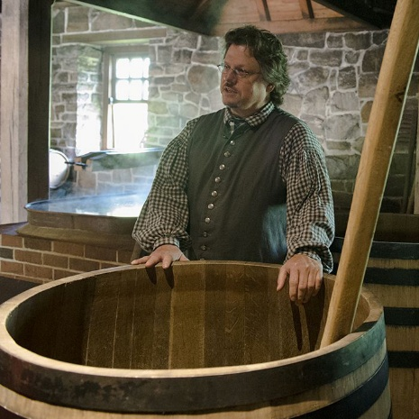
- Steve Bashore, Historian, Lecturer and Traditional Miller and Distiller – Steve has been involved in living history and museums for over 30 years and a traditional miller running water powered gristmills. Since 2007 until 2025 Steve was involved in making whiskey, brandy and other spirits in an 18th century manner, at George Washington’s Distillery at Mount Vernon. He has conducted thousands of tours, been on a wide variety of television shows, press interviews for television and radio, and podcasts, and he lectures regularly on historic topics. Details pending.

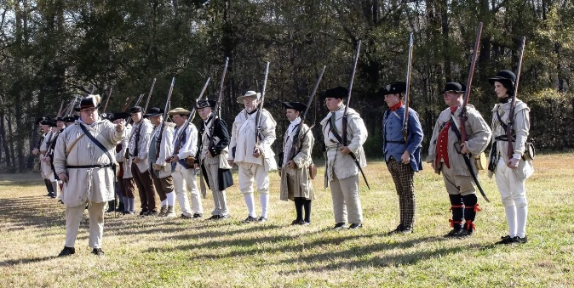
- Mark Dubin, Historic Weapons Safety Officer, Maryland Park Service, DNR – Mark has reserved the date for the Blues group of volunteers in uniform to attend the event; historic weapons demonstrations may be scheduled, pending an inspection of the site to ensure safety requirements are met.

- Mike Dixon – local historian and writer whose research and teaching focus on social history and community events. Mike will speak and provide historical information pertaining to the time period for the Revolutionary War and the Washington-Rochambeau Revolutionary Route, a network of roads and waterways (680 miles) used by allied forces in the march to and from the Siege of Yorktown. Specific details pending.

- Johnny Carawan, Trail Administrator, Washington-Rochambeau Revolutionary Route National Historic Trail (WARO) – supports the event and may have funds available to cover Dr. Selig’s expenses. He and/or other members of the organization will attend the event.

